**Packed Lunch Guidelines**

**To ensure consistency and to ensure a packed lunch is in line with Food Agency Standards, they MUST NOT contain the following:**

* All Nuts, nut containing products or nut products (we have children within our nursery with **SEVERE** nut allergies and we are a **NUT FREE** nursery)
* 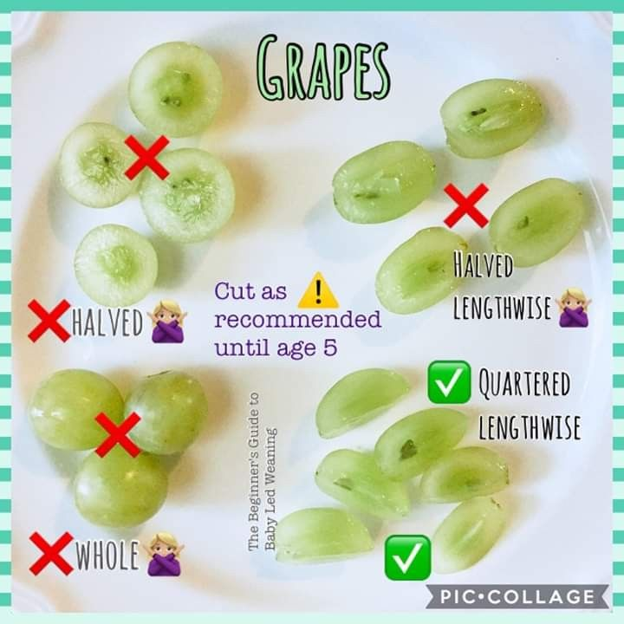Fizzy/sugary drinks in cartons, bottles or cans
* Confectionary including marshmallows, chocolate and sweets, popcorn and chewing gum
* Highly processed food such as Greggs, pizza etc

We ask that parents/carers provide a packed lunch container where food items can be stored securely and appropriately until the lunch time/teatime period. Lunch boxes are kept in the fridge, but we still ask that you provide an ice pack all year round as we may have the heating on.

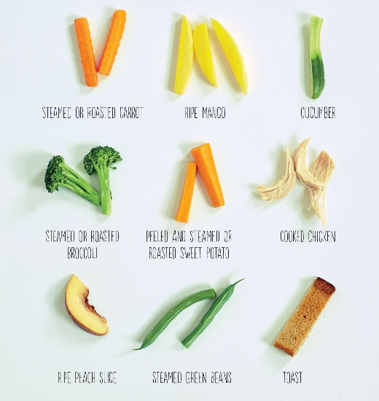We are **NOT** able to warm food up so please do not provide any foods that need heating up while at nursery. To limit the chance of choking we ask that all choking hazards, such as grapes, blueberries and sausages are cut into quarters lengthways as shown.

Each container of food needs to be labelled with then it is to be offered (e.g. AM snack, Lunch etc). If not enough food is provided we will ring to see if you can provide an alternative and if we cannot get hold of you or you are unable to bring additional food we will provide ours at the normal cost.

**Lunch Boxes/Provided Food**

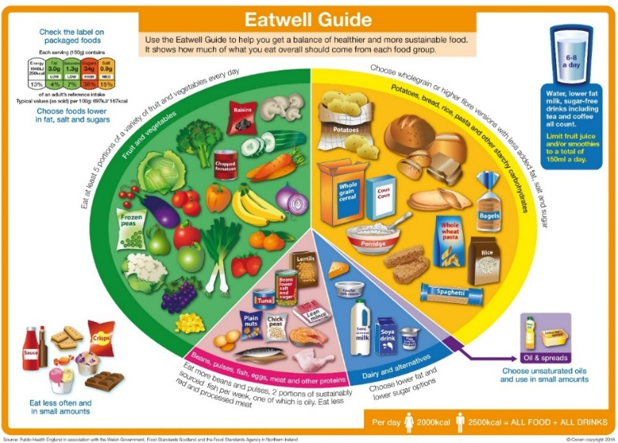A child’s packed lunch should be based on the ‘Eatwell Plate’ model which shows the 5 main food groups.

**Bread, Rice, Potatoes, Pasta** – these starchy foods are a healthy source of energy. Packed lunches should include 2 or more portions

**Fruit and Vegetables** – these foods provide vitamins, minerals and fibre. Lunches should include at least 1 portion of fruit and 1 portion of vegetables/salad or more

**Healthier snack options**

* Replace cakes and pastries with fruit bread and teacakes
* Replace salted savoury snacks such as, crisps with breadsticks, rice cakes, cheese and crackers etc
* Include dried fruit or fruit salad